 East West University
Department of CSE

Project Report
Project : Benchmarking of CPU speed.
Course Name: Computer Architecture
Course Code: CSE360
Section: 07 Group No. 09

Submitted To
MD. Adnan Morshed
Lecturer, Department of CSE
East West University

Submitted By
Name | ID
Sumaiya Rahaman | 2023-3-60-560
Fahim Raja | 2023-3-60-588
Riyadh Hossain | 2023-3-60-262
Efajul Islam Seyam | 2023-1-60-105
Tabassum Salsabil Ishpa | 2023-3-60-289

Date of Submission: 4/23/2026

Description:
This project is a CPU benchmarking tool implemented in C language. It is designed to measure the performance of different components of a computer system such as the processor, memory, and cache. The program runs several tests like integer operations, floating-point calculations, memory access, branch prediction, cache latency, and sorting. It uses high precision timing functions to calculate how fast each operation is executed. After completing all tests, the tool displays the performance results along with ratings like Excellent, Good, Fair, or Poor. This helps users easily understand the capability of their system. This project is very useful for learning important concepts of Computer Architecture, such as ALU performance, memory hierarchy, and CPU efficiency.
Objectives of the Project:
The main objectives of this project are:

1. Measure CPU Computation Performance
- To measure the speed of integer (ALU) operations in terms of MIPS
- To evaluate the efficiency of floating-point operations in terms of MFLOPS

2. Evaluate Memory Performance
- To measure memory read and write speed
- To determine the system’s memory bandwidth (GB/s)

3. Analyze Cache Efficiency
- To measure the latency of L1, L2, and L3 cache
- To compare the performance of different levels in the cache hierarchy

4. Measure Algorithm Performance
- To evaluate the execution speed of the sorting algorithm (qsort)
- To analyze the system’s capability to handle large datasets

Features of the CPU Benchmarking Tool:
1. Multi-Dimensional CPU Performance Testing
This project does not test just one thing—it evaluates multiple aspects of CPU performance together.

It covers:
- Computation speed
- Memory speed
- Cache efficiency
- Control flow behavior
- Algorithm performance
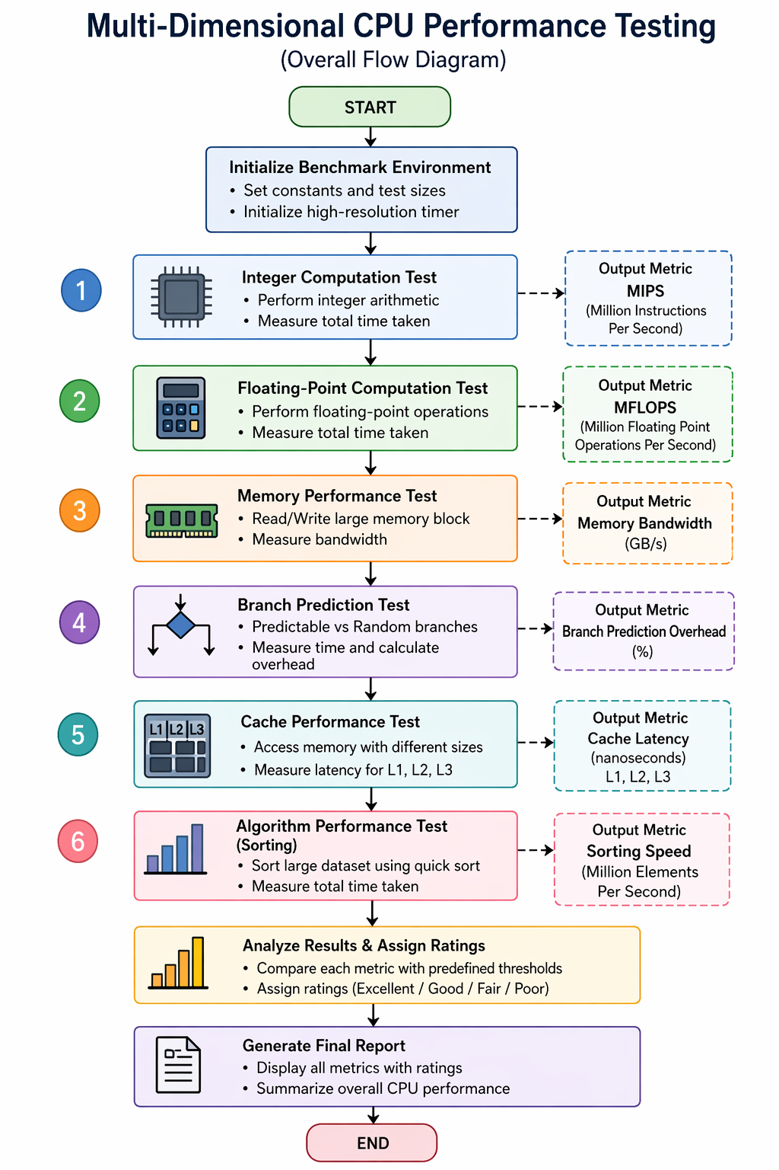
2. Integer Processing Benchmark (ALU Test)

Feature:
- Tests CPU’s Arithmetic Logic Unit (ALU)

How:
- Executes millions of integer operations:
  - addition
  - multiplication
  - modulo
  - bitwise operations

Output:
- MIPS (Million Instructions Per Second)

Importance:
- Represents performance of:
  - loops
  - basic programs
  - system-level operations
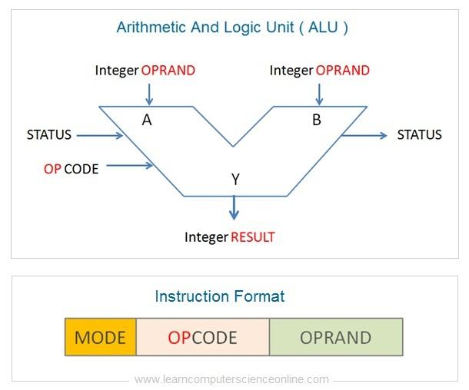
3. Floating Point Benchmark (FPU Test)

Feature:
- Tests Floating Point Unit (FPU)

How:
- Performs complex math:
  - decimal calculations
  - sqrt() function

Output:
- MFLOPS (Million Floating Point Operations Per Second)

Importance:
- Used in:
  - AI/ML
  - graphics
  - scientific computing
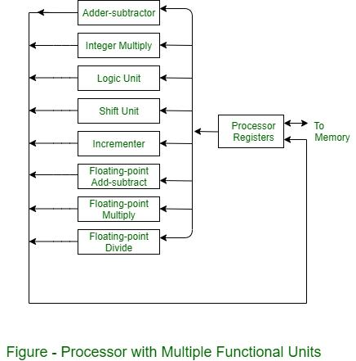

4. Memory Bandwidth Measurement

Feature:
- Measures data transfer speed between CPU and RAM

How:
- Allocates large memory block
- Repeatedly reads and writes data

Output:
- GB/s (Gigabytes per second)

Importance:
- Critical for:
  - big data processing
  - video rendering
  - large applications
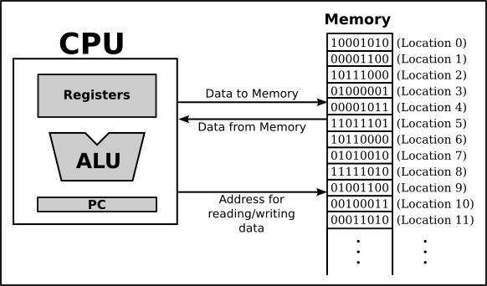

5. Branch Prediction Analysis

Feature:
- Evaluates CPU’s branch predictor

How:
- Compares:
  - predictable branches
  - random branches

Output:
- Overhead (%)

Importance:
- Modern CPUs guess if conditions
- Wrong guesses → pipeline stalls → performance drop
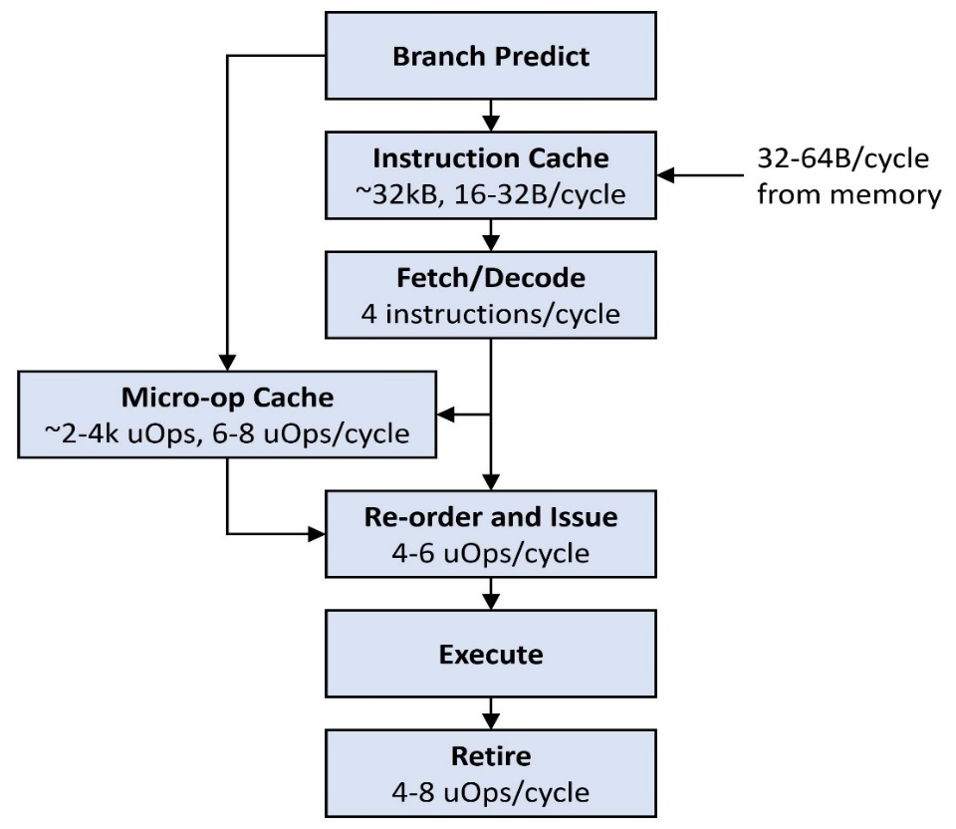

6. Cache Latency Testing (L1, L2, L3)

Feature:
- Tests cache memory speed

How:
- Uses pointer traversal (linked list technique)
- Measures access time for:
  - L1 cache
  - L2 cache
  - L3 cache

Output:
- Latency in nanoseconds (ns)

Importance:
- Cache is much faster than RAM
- Lower latency = better CPU performance
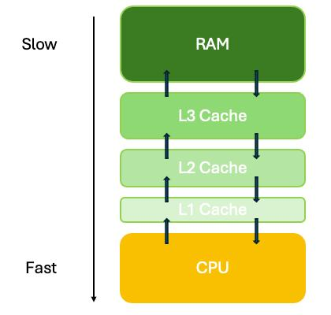
7. Sorting Performance Benchmark

Feature:
- Measures real-world algorithm performance

How:
- Generates random data
- Sorts using qsort()

Output:
- Million elements per second

Importance:
- Reflects:
  - CPU speed
  - memory efficiency
- Important for:
  - databases
  - searching systems
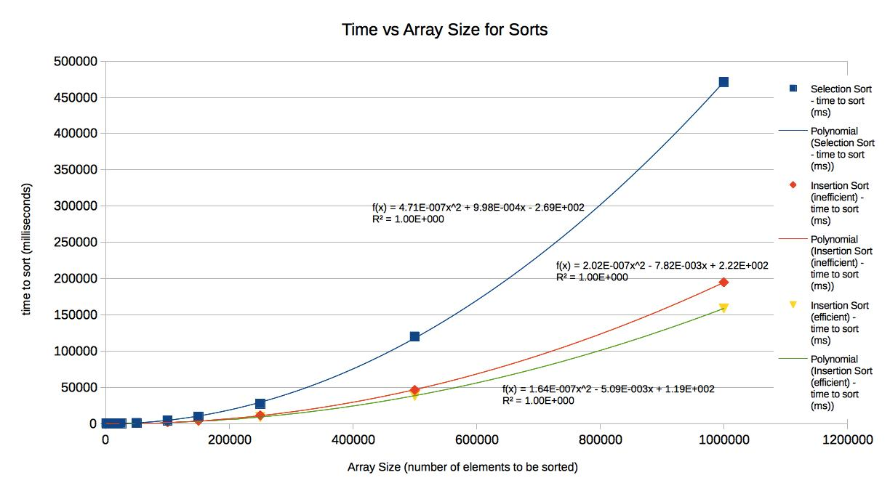

8. Cross-Platform High-Precision Timing

Feature:
- Supports:
  - Windows → high-resolution counter
  - Linux/macOS → monotonic clock

Importance:
- Ensures:
  - accurate timing
  - reliable benchmarking
- Makes program portable across systems

9. Dynamic Memory Handling

Feature:
- Uses malloc() and free()

Importance:
- Efficient memory usage
- Prevents memory leaks
- Handles large datasets safely

10. Performance Rating System

Feature:
- Converts raw scores into categories:
  - Excellent
  - Good
  - Fair
  - Poor

Importance:
- Makes results:
  - easy to understand
  - user-friendly
Program Code (C Language)
#include <stdio.h>
#include <stdlib.h>
#include <string.h>
#include <math.h>

/* ---------- Cross-platform timing ---------- */
#ifdef _WIN32
#include <windows.h>
typedef LARGE_INTEGER bench_time_t;

void get_time(bench_time_t *t) {
QueryPerformanceCounter(t);
}

double elapsed_sec(bench_time_t start, bench_time_t end) {
LARGE_INTEGER freq;
QueryPerformanceFrequency(&freq);
return (double)(end.QuadPart - start.QuadPart) / freq.QuadPart;
}

#else
#include <time.h>
typedef struct timespec bench_time_t;

void get_time(bench_time_t *t) {
clock_gettime(CLOCK_MONOTONIC, t);
}

double elapsed_sec(bench_time_t start, bench_time_t end) {
return (end.tv_sec - start.tv_sec) +
(end.tv_nsec - start.tv_nsec) * 1e-9;
}
#endif

/* ---------- Constants (reduced for faster run) ---------- */
#define ITER_INT 100000000LL
#define ITER_FP 50000000LL
#define MEM_BYTES (128*1024*1024)
#define MEM_PASSES 2
#define SORT_SIZE 1000000
#define BRANCH_ITER 100000000LL

#define L1_SIZE (32*1024)
#define L2_SIZE (256*1024)
#define L3_SIZE (4*1024*1024)
#define CACHE_STEPS 2000000

/* ---------- Rating ---------- */
const char* rating(double score, double p, double o, double g) {
if (score >= g) return "Excellent";
if (score >= o) return "Good";
if (score >= p) return "Fair";
return "Poor";
}

/* ---------- 1. Integer ---------- */
double bench_integer() {
volatile long long a = 3, b = 7, c = 0;
bench_time_t t0, t1;

get_time(&t0);
for (long long i = 0; i < ITER_INT; i++) {
c += a * b + i;
a = (c % 97) + 1;
b = (a + i) & 0xFFFF;
}
get_time(&t1);

return (ITER_INT * 3.0) / elapsed_sec(t0, t1) / 1e6;
}

/* ---------- 2. Floating ---------- */
double bench_float() {
volatile double x = 1.0, y = 2.0, z = 0.0;
bench_time_t t0, t1;

get_time(&t0);
for (long long i = 0; i < ITER_FP; i++) {
z = x * y + i * 1e-10;
x = sqrt(z + 1.0);
y = z * 0.9 + 1.0;
}
get_time(&t1);

return (ITER_FP * 5.0) / elapsed_sec(t0, t1) / 1e6;
}

/* ---------- 3. Memory ---------- */
double bench_memory() {
char *buf = malloc(MEM_BYTES);
if (!buf) return 0;

memset(buf, 1, MEM_BYTES);

bench_time_t t0, t1;
volatile long long sum = 0;

get_time(&t0);
for (int p = 0; p < MEM_PASSES; p++) {
memset(buf, p, MEM_BYTES);
for (size_t i = 0; i < MEM_BYTES; i += 64)
sum += buf[i];
}
get_time(&t1);

free(buf);
double bytes = MEM_BYTES * 2.0 * MEM_PASSES;
return bytes / elapsed_sec(t0, t1) / 1e9;
}

/* ---------- 4. Branch ---------- */
double bench_branch_predictable() {
volatile int c = 0;
bench_time_t t0, t1;

get_time(&t0);
for (long long i = 0; i < BRANCH_ITER; i++) {
if (i & 1) c++;
}
get_time(&t1);

return elapsed_sec(t0, t1);
}

double bench_branch_random() {
int *arr = malloc(BRANCH_ITER * sizeof(int));
if (!arr) return 0;

for (long long i = 0; i < BRANCH_ITER; i++)
arr[i] = rand() % 2;

volatile int c = 0;
bench_time_t t0, t1;

get_time(&t0);
for (long long i = 0; i < BRANCH_ITER; i++) {
if (arr[i]) c++;
}
get_time(&t1);

free(arr);
return elapsed_sec(t0, t1);
}

/* ---------- 5. Cache ---------- */
typedef struct Node {
struct Node *next;
} Node;

double walk_cache(size_t size) {
size_t n = size / sizeof(Node);
Node *nodes = malloc(n * sizeof(Node));
if (!nodes) return 0;

for (size_t i = 0; i < n - 1; i++)
nodes[i].next = &nodes[i + 1];
nodes[n - 1].next = &nodes[0];

Node *p = &nodes[0];

bench_time_t t0, t1;
get_time(&t0);
for (size_t i = 0; i < CACHE_STEPS; i++)
p = p->next;
get_time(&t1);

free(nodes);
return elapsed_sec(t0, t1) * 1e9 / CACHE_STEPS;
}

/* ---------- 6. Sorting ---------- */
int cmp(const void *a, const void *b) {
return (*(int*)a - *(int*)b);
}

double bench_sort() {
int *arr = malloc(SORT_SIZE * sizeof(int));
if (!arr) return 0;

for (int i = 0; i < SORT_SIZE; i++)
arr[i] = rand();

bench_time_t t0, t1;
get_time(&t0);
qsort(arr, SORT_SIZE, sizeof(int), cmp);
get_time(&t1);

free(arr);
return SORT_SIZE / elapsed_sec(t0, t1) / 1e6;
}

/* ---------- MAIN ---------- */
int main(void)
{
printf("CPU Benchmark Tool\n\n");

double mips = bench_integer();
printf("Integer ALU: %.1f MIPS (%s)\n",
mips, rating(mips, 500, 1500, 3000));

double mflops = bench_float();
printf("Floating Point: %.1f MFLOPS (%s)\n",
mflops, rating(mflops, 100, 500, 1500));

double gbps = bench_memory();
if (gbps > 0.0)
printf("Memory Bandwidth: %.2f GB/s (%s)\n",
gbps, rating(gbps, 5, 15, 30));
else
printf("Memory Bandwidth: Not enough memory\n");

double t1 = bench_branch_predictable();
double t2 = bench_branch_random();
double overhead = ((t2 - t1) / t1) * 100.0;

printf("Branch Predictor Overhead: %.1f%% (%s)\n",
overhead,
overhead < 10 ? "Excellent" :
overhead < 30 ? "Good" :
overhead < 70 ? "Fair" : "Weak");

double l1 = walk_cache(L1_SIZE);
double l2 = walk_cache(L2_SIZE);
double l3 = walk_cache(L3_SIZE);

printf("Cache Latency: L1=%.1f ns, L2=%.1f ns, L3=%.1f ns\n",
l1, l2, l3);
double sort = bench_sort();
if (sort > 0.0)
printf("Sorting: %.2f M elements/sec (%s)\n",
sort, rating(sort, 5, 20, 50));
else
printf("Sorting: Not enough memory\n");
return 0;
}

Image of the output :
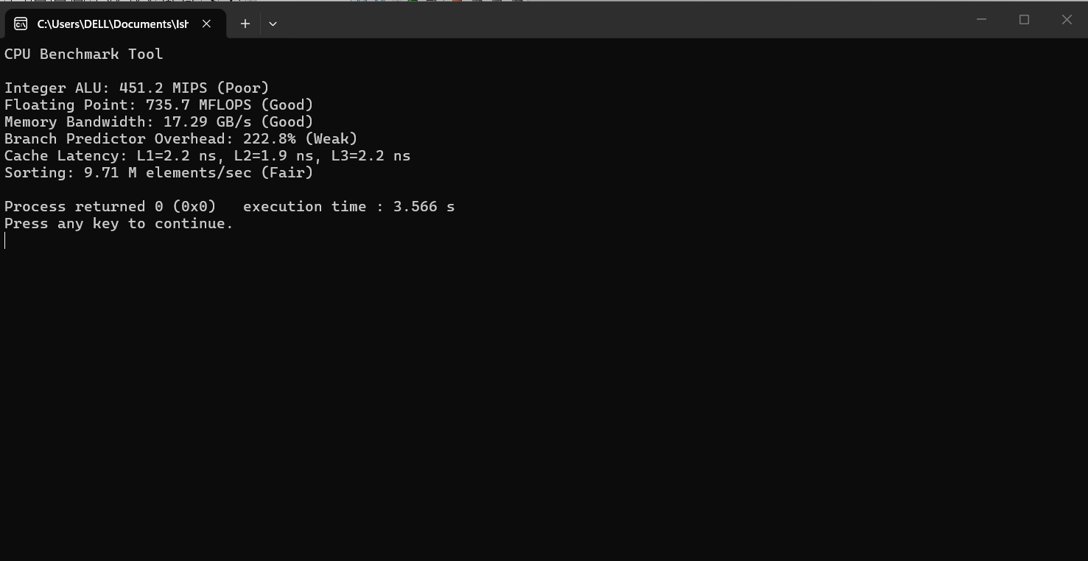

Final Conclusion: This project is a complete CPU benchmarking tool that evaluates processor performance across computation, memory access, cache efficiency, control flow, and algorithm execution using precise timing techniques.

